200929168

Nihar Ramesh Bhandary

LAB3

Example 1

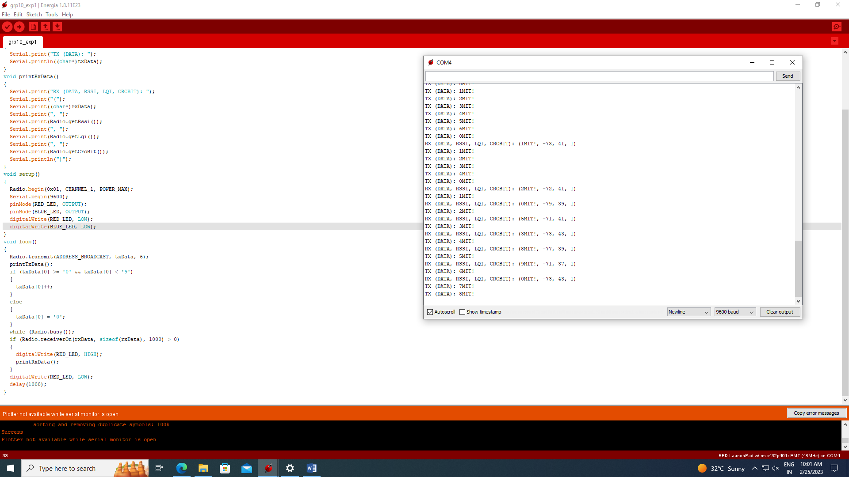

Q1

#include <SPI.h>   
#include <AIR430BoostETSI.h>   
int launchpadButtonState = 0;   
int launchpadButtonState2 = 0;

unsigned char txData_1[1000] = {'e', 'n', 't', 'e', 'r', 'e', 'd', '\0' };

unsigned char txData_2[1000] = {'e', 'x', 'i', 't', '\0' };  
unsigned char rxData[1000] = { '\0', '\0', '\0', '\0', '\0', '\0' };  
void printTxData_1()

{   
  //Serial.print("TX (DATA): ");   
  Serial.println((char*)txData_1);    
}

void printTxData_2()

{   
  //Serial.print("TX (DATA): ");   
  Serial.println((char*)txData_2);    
}   
void printRxData()   
{   
  Serial.print("RX (DATA, RSSI, LQI, CRCBIT): ");   
  Serial.print("(");   
  Serial.print((char*)rxData);   
  Serial.print(", ");   
  Serial.print(Radio.getRssi());   
  Serial.print(", ");   
  Serial.print(Radio.getLqi());   
  Serial.print(", ");   
  Serial.print(Radio.getCrcBit());   
  Serial.println(")");   
}   
void setup()   
{   
  Radio.begin(0x01, CHANNEL_1, POWER_MAX);  
  Serial.begin(9600);     
  pinMode(RED_LED, OUTPUT);  
  pinMode(GREEN_LED, OUTPUT);  
  digitalWrite(RED_LED, LOW);  
  digitalWrite(GREEN_LED, LOW);    
  pinMode(PUSH1, INPUT_PULLUP);  
  pinMode(PUSH2, INPUT_PULLUP);   
}   
void loop()   
{   
  Radio.transmit(ADDRESS_BROADCAST, txData, 6);  
 // printTxData();      
  launchpadButtonState = digitalRead( PUSH1);  
  launchpadButtonState2 = digitalRead( PUSH2);

if (launchpadButtonState == 0){  
      digitalWrite(GREEN_LED, HIGH);  
      digitalWrite(RED_LED,LOW);

printTxData_1();     
  }

if (launchpadButtonState2 == 0){  
      digitalWrite(GREEN_LED, LOW);  
      digitalWrite(RED_LED,HIGH);

printTxData_2();     
  }

else{

digitalWrite(GREEN_LED, LOW);  
      digitalWrite(RED_LED,LOW);

}

}

/*while (Radio.busy());  
  if (Radio.receiverOn(rxData, sizeof(rxData), 1000) > 0)   
  {   
    digitalWrite(RED_LED, HIGH);       
    printRxData();   
  }   
  digitalWrite(RED_LED, LOW);     
  delay(1000);*/

Q2

#include <SPI.h>   
#include <AIR430BoostETSI.h>   
int launchpadButtonState = 0;   
int launchpadButtonState2 = 0;  
int x = 1;  
unsigned char txData[6] = { 0x30, launchpadButtonState, '\0' };  
unsigned char rxData[6] = { '\0', '\0', '\0', '\0', '\0', '\0' };  
void printTxData()

{   
  Serial.print("TX (DATA): ");   
  Serial.println((char*)txData);    
}   
void printRxData()   
{   
  Serial.print("RX (DATA, RSSI, LQI, CRCBIT): ");   
  Serial.print("(");   
  Serial.print((char*)rxData);   
  Serial.print(", ");   
  Serial.print(Radio.getRssi());   
  Serial.print(", ");   
  Serial.print(Radio.getLqi());   
  Serial.print(", ");   
  Serial.print(Radio.getCrcBit());   
  Serial.println(")");   
}   
void setup()   
{   
  Radio.begin(0x01, CHANNEL_1, POWER_MAX);  
  Serial.begin(9600);     
  pinMode(RED_LED, OUTPUT);  
  pinMode(GREEN_LED, OUTPUT);  
  digitalWrite(RED_LED, LOW);  
  digitalWrite(GREEN_LED, LOW);    
  pinMode(PUSH1, INPUT_PULLUP);  
  pinMode(PUSH2, INPUT_PULLUP);   
}   
void loop()   
{   
  Radio.transmit(ADDRESS_BROADCAST, txData, 6);  
  printTxData();      
  launchpadButtonState = digitalRead( PUSH1);  
  launchpadButtonState2 = digitalRead( PUSH2);  
  /*while(!x){  
  if (launchpadButtonState != 0){  
      digitalWrite(GREEN_LED, HIGH);  
  if(launchpadButtonState != 0){  
        x = 0;}  
  }  
  digitalWrite(GREEN_LED, LOW);  
  digitalWrite(RED_LED, HIGH);*/  
  if (launchpadButtonState != 0){  
      digitalWrite(GREEN_LED, HIGH);  
      digitalWrite(RED_LED,LOW);  
  
  }  
  if(launchpadButtonState == 0){  
  
  digitalWrite(GREEN_LED, LOW);  
  while(1){  
  digitalWrite(RED_LED,HIGH);  
  }  
  
  
  
  }  
  
  }

  while (Radio.busy());  
  if (Radio.receiverOn(rxData, sizeof(rxData), 1000) > 0)   
  {   
    digitalWrite(RED_LED, HIGH);       
    printRxData();   
  }   
  digitalWrite(RED_LED, LOW);     
  delay(1000);